**Infection Control and Prevention Policy and Procedures**

|  |  |
| --- | --- |
| Version | V1 |
| Author |  |
| Author title | Infection Control Lead Nurse |
| Review date | Dec 2025 |

**Policy Summary**

The St. Martins Medical Centre is committed to ensuring safe, effective, compassionate and high-quality care; the organisation acknowledges that effective infection prevention and control (IPC) is essential to protect people from acquiring infections and to ensure action is taken to minimise the risk of cross-infection.

The St. Martins Medical Centre recognises that all members of staff are responsible for the prevention and control of infection and for ensuring excellent standards of basic hygiene.

The St. Martins Medical Centre is committed to minimising the risk of infection to both patients and staff through the provision of mandatory training for all members of staff, appropriate equipment and access to policies and procedures to prevent and control infection.

**Contents**

|  |  |  |
| --- | --- | --- |
|  | | Page |
|  | Introduction | 4 |
|  | Purpose | 4 |
|  | Objective | 5 |
|  | Scope | 5 |
|  | Policy | 6 |
|  | Duties and responsibilities | 7 |
|  | Training | 7 |
|  | Staff sickness | 7 |
|  | Uniform and work wear | 8 |
|  | References | 8 |
|  | Monitoring | 9 |
|  | Review | 9 |

**Appendices**

|  |  |  |
| --- | --- | --- |
|  | | Page |
|  | CQC Key Lines of Enquiry (KLOE) | 10 |
|  | Procedures |  |
|  | 1. Handwashing | 11 |
|  | 1. Choice of Hand Washing Agents | 12 |
|  | 1. Handwashing Technique using Liquid Soap | 13 |
|  | 1. Using Alcohol Gel / Liquid | 14 |
|  | 1. Use of Gloves | 15 |
|  | 1. Water Temperature | 16 |
|  | 1. Emollient | 16 |
|  | 1. Skin Damage | 16 |
|  | 1. Hand Drying | 16 |
|  | 1. Bare Below the Elbows | 16 |
|  | 1. Respiratory Hygiene and Cough Etiquette | 17 |
|  | 1. Personal and Protective Equipment (PPE) | 18 |
|  | 1. Occupational Exposure Management Including Needlestick (or Sharps) Injuries | 19 |
|  | 1. What Does Needlestick (or Sharps) Injury Mean? | 20 |
|  | 1. Actions in the event of an occupational exposure including a needlestick or similar injury | 20 |
|  | 1. Management of Clinical Sharps – Good Practice | 21 |
|  | 1. Blood Borne Viruses (BBVs) | 22 |
|  | 1. Human Bite | 23 |
|  | 1. Animal Bite | 23 |
|  | 1. All Spillages of Body Fluids (e.g. urine, vomit, faeces or blood) Should Be Dealt with Immediately | 24 |
|  | 1. Outbreaks of Communicable Diseases | 24 |
|  | 1. Skin Infections / Infestations | 24 |
|  | 1. Disposal of Waste | 25 |
|  | 1. Sepsis | 26 |
|  | 1. Reporting | 27-28 |
| 3 | Definition of Terms | 29 -35 |
|  | Equality and Health inequalities Analysis of the policy | 35-37 |

1. **Introduction**

This policy and procedures outlined, backdrop from the national and international published best practice guidelines for Infection Control and Prevention. The policy will be reviewed and updated as new information becomes available, to guide best practice.

In the event of any national outbreaks or disasters e.g. Covid 19, national guidelines on Infection Control and Prevention take precedence and must be adhered to by all staff.

1. **Purpose**

This document outlines the principles of infection prevention and control according to best practice and evidence base, will be made available to all staff members who have contact with service users, with the aim of break the chain of infection at every point and reducing the spread of infection – see Figure 1.

To comply with the Health and Social Care Act 2008 Code of Practice on the prevention and control of infections and related guidance (July 2015).

To comply with CQC Key Lines of Enquiry – see appendix 1.

To comply with all mandatory requirements and best practice infection prevention and control guidelines for the safe delivery of primary care in the general practice environment.

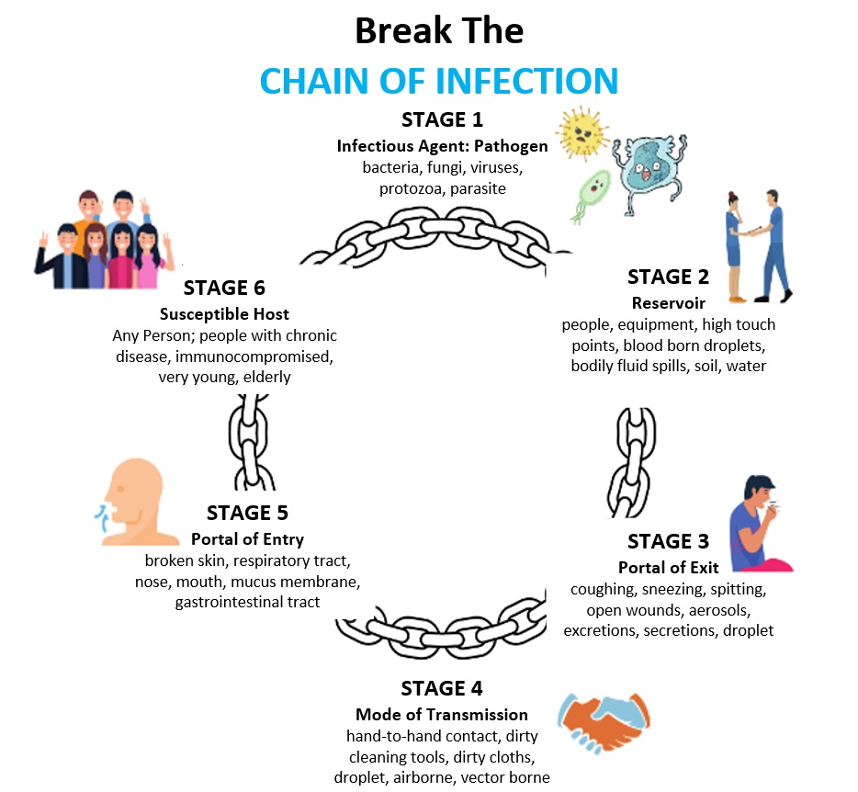

Figure 1. Break The Chain of Infection.

1. **Objective**

To have and operate systems to manage and monitor the prevention and control of infection.

To assess infection control risks to patients, the services and members of staff and the public.

To ensure prompt identification of patients and others who have or are at risk of developing an infection during service use or service providing.

1. **Scope**

To have and operate systems to manage and monitor the prevention and control of infection.

To assess infection control risks to patients, the services and members of staff and the public.

To ensure prompt identification of patients and others who have or are at risk of developing an infection during service use or service providing.

1. **Policy**

The St. Martins Medical Centre, Hillingdon recognises that all members of staff are responsible for the prevention and control of infection and are committed to minimising the risk of infection to staff, patients and other users by ensuring excellent standards of basic hygiene and insisting on and continuously monitoring and keeping documented, universal infection prevention and control procedures.

The St. Martins Medical Centre, Hillingdon is committed to minimising the risk of infection to staff and patients by providing all members of staff with appropriate training and equipment as well as access to policies and procedures to prevent and control infection.

The organisation will make sure that risks are identified and measures to control or prevent these risks are clearly documented and cascaded to all members of staff.

Staff will receive appropriate training and equipment for the prevention and control of infection; and will understand the importance of excellent hand hygiene and how to use Personal Protective Equipment (PPE).

The organisation is responsible for the prevention of the spread of blood-borne viruses, for the safe use of sharps and the safe disposal of clinical and biological waste.

The Infection Prevention and Control Lead (IPCL) will guide adherence to this policy, procedure and any associated guidance and will oversee compliance with The Health and Social Care Act 2008 Code of Practice on the prevention and control of infections and related guidance.

The IPCL in line with *The Health and Social Care Code of Practice on the prevention and control of infections and related guidance (2015)* will:

* Be responsible for infection prevention (including cleanliness) management.
* Be responsible for and oversee local prevention and control of infection policies and their implementation.
* Ensure that the Partners are kept up to date on matters relating to the prevention and control of infection.
* Ensure that all internal and external reporting and recording arrangements are adhered to.
* Be able challenge unsafe or inappropriate practice.
* Set, monitor and challenge standards of cleanliness.
* Assess the impact of all existing and new policies on infection prevention and control and make recommendations for change.

1. **Duties and Responsibilities**

The Infection Prevention Lead Nurse will support The St. Martins Medical Centre, clinical teams to adhere to the procedures contained in this policy; and oversee compliance with The Health and Social Care Act 2008 Code of Practice on the prevention and control of infections and related guidance.

**Communication**

* The St. Martins Medical Centre, will ensure that all staff members (including contractors and volunteers) are aware of and discharge their responsibilities in the process of preventing and controlling infection.
* This could be done through, but is not limited to, job descriptions, induction, training, supervision and team meetings.
* Contractors working in patient areas must be made aware of any issues with regard to infection prevention and obtain ‘permission to work’.
* Where staff undertake procedures, which require skills such as aseptic technique, they must be trained and demonstrate proficiency before being allowed to undertake these procedures independently.
* The St. Martins Medical Centre will ensure that its policy on the prevention and control of infection is available to visiting healthcare professionals and professions allied to medicine to prevent and control infection while they are working with patients.
* Outcomes of investigations into incidents must be shared with the person concerned and, where relevant, their families, carers and advocates. This is in keeping with Regulation 20 Duty of Candour.

1. **Training**

Partners are responsible for ensuring that their staff access the correct level of training and are compliant.

* + - All staff should be made aware of this policy and should be trained appropriately to ensure that they are suitably skilled and competent and able to advise carers and volunteers on infection prevention and control in relation to keeping patients protected from acquiring infection.

1. **Staff Sickness**

* Staff with diarrhoea and vomiting should not attend work but phone their line manager to report their sickness.
* Should the condition persist, it may be necessary to not return to work until medical clearance by a GP is given.
* Staff should not attend work until they are clear for 48 hours in order to prevent the spread of infection.

1. **Uniform and Work wear**

Effective hygiene and preventing infection are absolutes in all care settings. Although there is no conclusive evidence that uniforms and work wear play a direct role in spreading infection, the clothes that staff wear should facilitate good practice and minimise any risk to patients. Uniforms and work wear should not impede effective hand hygiene and should not unintentionally come into contact with patients during the course of examination, diagnosis, treatment or primary care interventions of any kind.

* Staff should wear gloves and aprons when deemed appropriate - not 'just in case'.
* Staff should change as soon as possible if their uniform or clothing becomes visibly soiled or contaminated.
* Wash uniforms and clothing worn at work at the hottest temperature suitable for the fabric.
* Clean washing machines and tumble driers regularly in accordance with the manufacturer’s instructions.
* Staff should have at least enough uniforms available to change each day or to reasonably enable staff to start each day with a clean uniform.
* Staff should wash heavily soiled uniforms separately.
* Separate washing of uniforms will eliminate any possible cross-contamination from high levels of soiling and enable the uniform to be washed at the highest recommended temperature.

1. **References**

* Infection Prevention and Control - Resources for General Practice: <https://www.infectionpreventioncontrol.co.uk/content/uploads/2018/12/GP-IPC-Resource-Booklet-Sept-2018-19.pdf>
* How to Recognise Sepsis - A Checklist for Community Care Staff:

<https://sepsistrust.org/wp-content/uploads/2018/06/Community-carers-NICE-Final-2.pdf>

* Five Moments of Hand Hygiene, WHO:

<http://www.who.int/gpsc/5may/background/5moments/en/>

* Clean Care is Safer Care - Clean hands protect against infection WHO <http://www.who.int/gpsc/clean_hands_protection/en/>
* Health Protection Agency: 2013: Prevention and Control of Infection in Care Homes - an information resource:

<https://www.gov.uk/government/uploads/system/uploads/attachment_data/file/214929/Care-home-resource-18-> [February-2013.pdf](https://www.gov.uk/government/uploads/system/uploads/attachment_data/file/214929/Care-home-resource-18-February-2013.pdf)

* IPC Bulletin for GP Practice Staff:

<https://www.infectionpreventioncontrol.co.uk/news/ipc-bulletin-for-gp-practice-staff/>

1. **Monitoring and Evaluation**

The Infection Control Policy compliance will be monitored by yearly infection control audits (or more frequently if required); audits carried out by practice Infection Control Lead or externally invited organisations. Infection Control Champions [EGS] in the practice (Environmental, hand hygiene, BBE, and medical devices) and any other audit/inspection as considered appropriate by the IPC lead.

The St. Martins Medical Centre will:

* Ensure non-compliance with any of these procedures are reported through the Incident reporting process
* Ensure that there is evidence of appropriate action taken to prevent and control infection.
* Conduct an annual report on infection prevention and control.
* In accordance with health and safety requirements, ensure risks assessments are conducted and appropriate actions taken.
* Review this policy annually or earlier in the event of any national guidance or legislative changes

1. **Review**

This policy will be reviewed in three years or sooner if there is a local or national requirement.

**Appendix 1**

|  |  |
| --- | --- |
| **CQC Key Lines of Enquiry (KLOE)** | |
| Safe | S5.1 What are the arrangements for making sure that premises are kept clean and hygienic so that people are protected from infections that could affect both staff and people using services? |
| Safe | S5.2 Do staff understand their roles and responsibilities in relation to infection control and hygiene? |
| Safe | S5.3 Are policies and procedures maintained and followed in line with current relevant national guidance? |
| Safe | S5.4 Where it is part of the service’s role to respond to and help to manage infections, how does the service make sure that it alerts the right external agencies to concerns that affect people’s health and wellbeing? |

**Appendix 2**

**Procedures**

1. **Handwashing**

Most healthcare-associated infections are preventable through good hand hygiene, by cleaning hands at the right times and in the right way. The aim of routine hand washing is to remove dirt and most transient micro- organisms (germs that can be easily removed by hand washing) found on the hands. In caring for patients, 5 moments for hand hygiene must be observed.

All clinical staff should wash their hands:

* Before starting work
* Before eating, preparing or handling food
* Before and after administering treatment or interventions of every kind
* Before and after physical contact with patients
* After any activity that contaminates the hands
* After using the toilet
* After sneezing/blowing the nose
* After cleaning activities
* Before going home
* After all other occasions when hands are thought to have been subject to contamination of any kind.

Figure 3. Your five moments for hand hygiene at the point of care

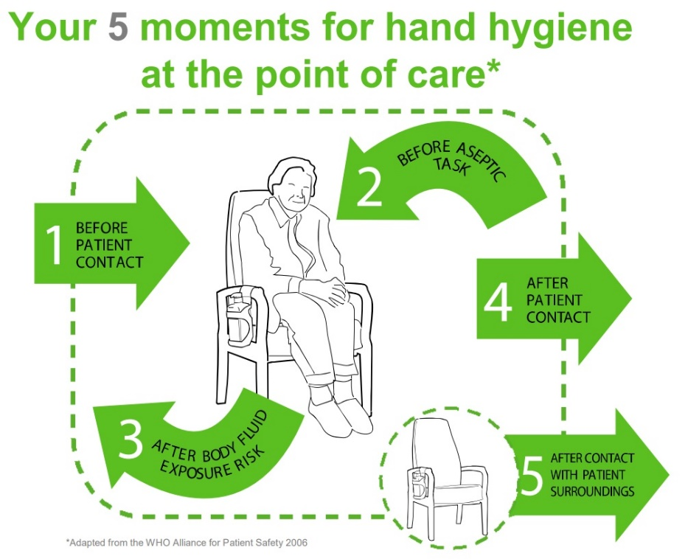

1. **Choice of Hand Washing Agents**

Hand washing can be improved by the provision of adequate and conveniently located facilities. Good hand preparation decreases the risk of contamination. However, in a home setting (e.g. when

visiting a patient), this is not always available.

* **Liquid Soap**

Hand washing with liquid soap and water removes dirt and organic material and should be used:

* Before and after physical contact (usually via physical examination) with a patient.
* Following direct hand contact with body fluids when gloves should have been worn.
* When hands are visibly dirty or visibly soiled with body fluids and other organic matter.
* After several consecutive applications of alcohol gel/rub.
* **Alcohol**

There are many different products sold as disinfectant hand-rubs, but according to the World Health Organisation (WHO), alcohol-based hand-rubs are the only products to reduce or inhibit the growth of microorganisms with maximum efficiency.

The hand-rub should contain 60-80% alcohol. Alcohol gel/rub is not effective when hands are dirty or soiled. It will not remove dirt or organic material and is not effective against some organisms e.g. Clostridium Difficile and Norovirus.

Hands must be decontaminated with alcohol gel/rub before invasive tasks such as dressings (wash hands first with soap and water if visibly soiled).

Alcohol gel/rub works very well and is more effective than soap and water at disinfecting physically clean hands. Alcohol gel/rub is flammable and must be correctly stored.

* **Bar Soap**

Bacteria can grow on bar soap, especially if it is resting in water, it should not be used.

1. **Handwashing Technique using Liquid Soap**

* Expose the wrists and forearms, all parts of the hands must be included in the process.
* Wet hands under running warm water before applying soap.
* Apply liquid soap in the recommended product volume.
* Rub all parts of the hands vigorously, without applying more water, using the six-step technique.
* Rinse under running water.
* Hand washing should take 40-60 seconds and a useful tip to check you are washing your hands for the right amount of time is to sing 'Happy Birthday' twice.

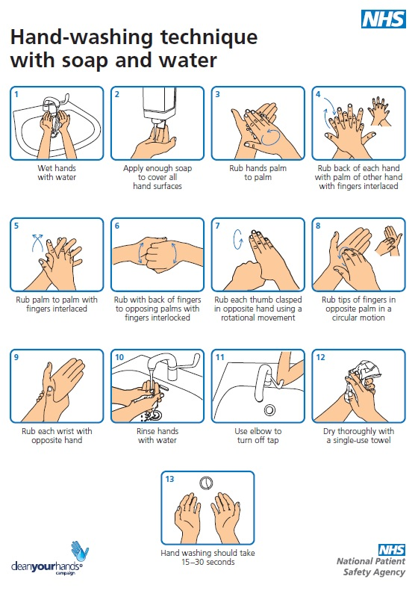

Figure 4. Handwashing Technique using Liquid Soap

1. **Using Alcohol Gel / Liquid**

* Hands must be free from dirt and organic matter, if not, wash first.
* Avoid using excessive amounts of alcohol gel/rub to minimise skin damage. Apply one shot (approx. 5 ml) of alcohol hand rub.
* The hand rub must come into contact with all surfaces of the hands so hands must be rubbed together vigorously and systemically to include wrists, tips of fingers, backs of hands, palms, thumbs and webs of fingers for ten to fifteen seconds or until the solution has evaporated.

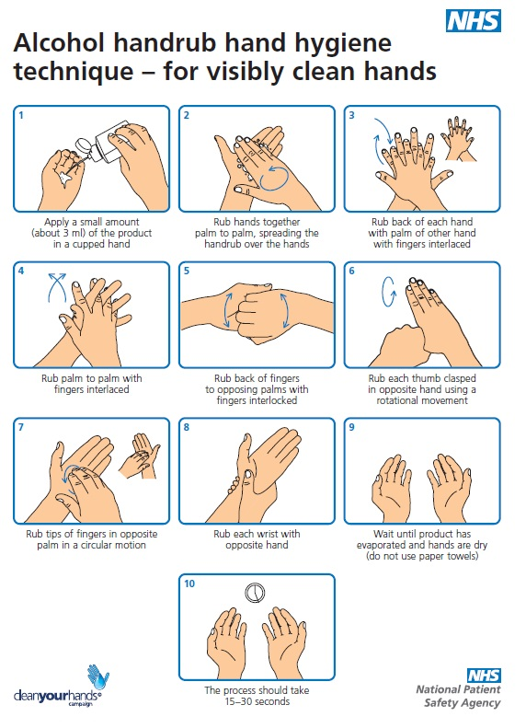

Figure 5. Using Alcohol Gel / Liquid.

1. **Use of Gloves**

The use of gloves does not replace the need for hand hygiene.

Gloves are single use only and should be changed between patients or following certain procedures on the same patient.

Gloved hands should not be washed or cleaned with alcohol hand rub.

Hands should be washed after the removal of gloves.

1. **Water Temperature**

Contact time and friction are more important than the temperature of water; however, for staff comfort water should be warm.

1. **Emollients**

Although emollients are now standard ingredients in most liquid soaps and alcohol rubs (this is sometimes a substance called Lanolin), some staff may experience prolonged soreness or sensitisation, and this should be discussed with the Infection Prevention and Control Lead or your Line Manager.

1. **Skin Damage**

Skin damage may be associated with a poor hand washing technique or the frequent use of hand hygiene agents. Excoriated hands are associated with increased growth of germs and increase the risk of infection. Irritant and hand drying effects of hand preparations are one of the reasons why staff fail to follow hand hygiene guidelines.

The best practice below will help to prevent skin damage:

* Staff to be aware of potentially damaging effects of hand hygiene products.
* Avoid putting on gloves while hands are still wet from washing or applying alcohol rub.
* Avoid rubbing hands with paper towels; skin should be patted dry.
* Avoid over-use of gloves.
* Use emollient hand cream regularly, e.g. after washing hands, before breaks, when going off duty and when off duty.
* If irritation occurs, review compliance with the hand decontamination technique and then inform the Infection Prevention and Control Lead and/or your Line Manager.
* Avoid communal ‘pots’ of moisturiser as they can become a potential source of infection.
* Individual tubes of hand creams may be used provided that care is taken not to contaminate the nozzle.

1. **Hand Drying**

Dry hands thoroughly**.** Improper drying can re-contaminate hands that have been washed. Correct drying can further reduce the risk of micro-organisms remaining on the hands after washing. Wet surfaces transfer organisms more effectively than dry ones and inadequately dried hands are prone to skin damage. Where possible, disposable paper towels should be used to ensure that hands are dried thoroughly.

1. **Bare Below the Elbows**

In November 2007 the Department of Health announced that health providers should adopt ‘Bare Below the Elbows’ policy whilst providing or undertaking care procedures. 'Bare Below the Elbows' is where the hands and arms up to the elbow/mid forearm are exposed and free from clothing/jewellery.

To control and prevent the spread of infection, the organization will ensure that staff understand the following best practice:

* Nails should be short and clean and there should be no nail polish or extensions.
* Wrist watches should not be worn. No other jewellery should be worn around the wrist.
* Alert bracelets should be removed and attached around a lanyard or pinned to the uniform.
* No rings with stones should be worn but one plain band is acceptable.

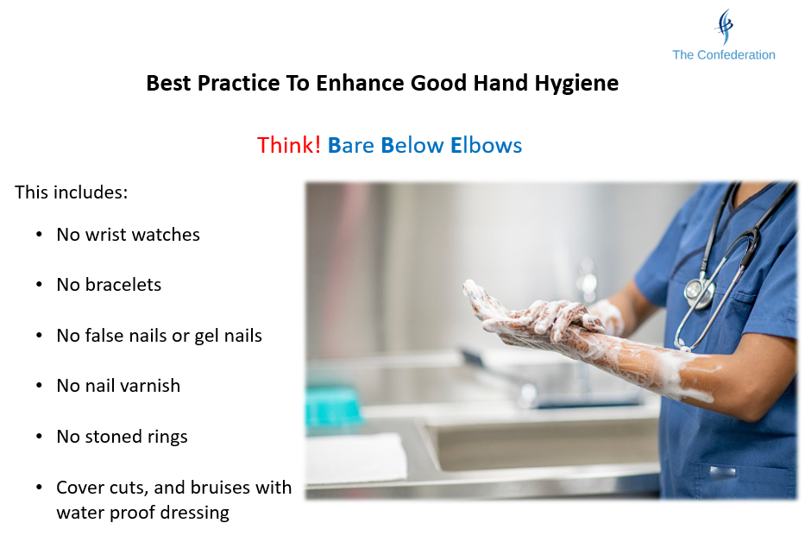

Figure 6. Best Practice - Enhance Good Hand Hygiene - Think! Bare Below Elbows

1. **Respiratory Hygiene and Cough Etiquette**

Respiratory hygiene and cough etiquette should always be applied as a standard infection prevention and control precaution.

The measures include:

* Cover nose and mouth with disposable single use tissues when sneezing, coughing, wiping and blowing the nose.
* Dispose of used tissues into a waste bin immediately after use.
* Wash hands with soap and water after coughing, sneezing, using tissues or after contact with respiratory secretions or objects contaminated by these secretions.
* Keep contaminated hands away from the mucous membranes of the eyes and nose.

1. **Personal and Protective Equipment (PPE)**

* Staff should wear PPE if there is a risk of exposure to blood or body fluids.
* PPE includes gloves, aprons and occasionally masks if there is a risk of airborne infections.
* Overshoes are unlikely to be required in a patient's home or in a care home. Visiting staff should be aware that the use of overshoes increases the risk of slips, trips and falls.
* Gloves must be removed by holding at the cuff and peeling the glove over the hand. Then fold the second glove off the hand over the first glove, enclosing the first glove within the second glove and disposing of the gloves into the household waste.

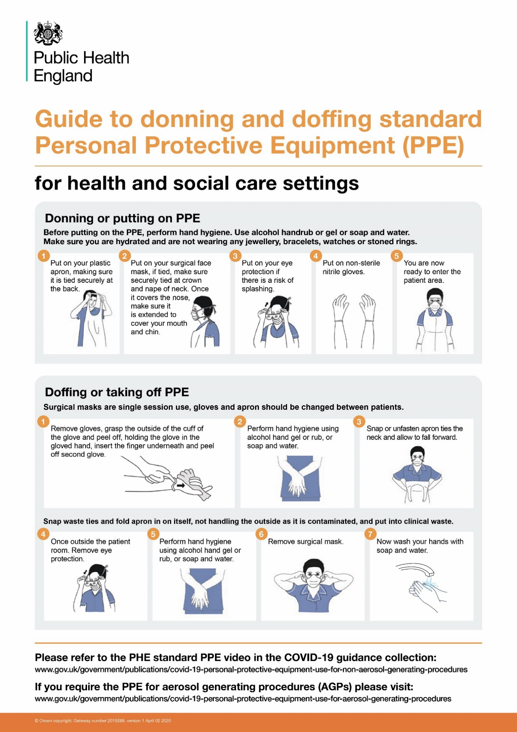

Figure 7. Guide to Donning and Doffing Standard Personal Protection Equipment (PPE)

1. **Occupational Exposure Management Including Needlestick (or Sharps) Injuries**

Needlestick or “sharps” injuries are one of the most common types of injury reported by healthcare staff. The greatest occupational risk of transmission of a Blood Borne Virus (BBV) is through parenteral exposure, e.g. a needlestick injury, particularly involving hollow-bore needles.

Blood and body fluids, such as saliva, semen and vaginal fluid, can contain viruses that can be passed on to other people. If you have contact with a person’s blood or body fluids you could be at risk of HIV, Hepatitis B or Hepatitis C, or other blood-borne illnesses. Body fluids, such as sweat, tears, vomit or urine may contain and pass on these viruses when blood is present in the fluid, butthe risk is low.

Risks also exist from splashes of blood/body fluids/excretions/secretions, particularly to mucous membranes; however, this risk is smaller.

There is currently no evidence that BBVs can be transmitted through intact skin, inhalation or through the faecal- oral route.

1. **What Does Needlestick (or Sharps) Injury Mean?**

For the purposes of this Policy and Procedure, the definition of a needlestick (or sharps) includes items such as needles, sharp-edged instruments, broken glassware, any other item that may be contaminated with blood or body fluids and may cause laceration or a puncture wound. This could include razors, sharp matter/tissue or spicules of bone and teeth.

Occupational exposure including needlestick (or sharps) injury refers to the following injuries or exposure:

* Percutaneous injury (from needles, instruments, bone fragments, human bites which break the skin)
* Exposure of broken skin (abrasions, cuts, eczema etc.)
* Exposure of mucous membranes including the eyes, nose and/or mouth.

1. **Actions in the event of an occupational exposure including a needlestick or similar injury**

Perform first aid to the exposed area immediately as follows:

* Skin/tissues should be gently encouraged to bleed.
* Do not scrub or suck the area.
* Wash/irrigate with soap and warm running water. Do not use disinfectants or alcohol.
* Cover the area using a waterproof dressing.
* Eyes and mouth should be rinsed/irrigated with copious amounts of water.
* If contact lenses are worn, irrigation should be performed before and after their removal; do not replace the contact lens.
* Do not swallow the water which has been used for mouth rinsing.
* Refer Occupational Health Department,   
  7A Woodfield Road,   
  London,   
  W9 2NW Phone: [020 3317 3350](tel:020%203317%203350) Email: [cnwl.occupationalhealth@nhs.net](mailto:cnwl.occupationalhealth@nhs.net)
* For more information about making the referral please visit <https://occupationalhealthnwl.nhs.uk/about/cnwl-occupational-health-service/referrals-frequently-asked-questions>

1. **Management of Clinical Sharps – Good Practice**

* Sharps should be stored safely out of reach of children.
* Clinical sharps are single use only.
* Needles should not be re-sheathed; needles that are bent or broken should be disposed of before use.
* Syringes and needles are to be disposed of as a single unit and not dismantled by hand.
* The user must discard sharps immediately after use directly into a sharps container.
* The sharps container must conform to UN standard 3291 and British Standard 7320.
* Approved sharps containers should be assembled correctly and should never be over-filled, i.e. above the manufacturers’ fill line on the box/more than ¾ full.
* Sharps containers should be appropriately sealed in accordance with manufacturers’ instructions once full, and should be disposed of according to the local clinical waste disposal policy and procedure.
* Items should never be removed from sharps containers. The temporary closure mechanism on sharps containers should be used in between each use/disposal for safety.
* The label on the sharps containers must be completed when starting to use the container and again once sealed to facilitate tracing if required.
* If carrying the container, or when it is left unsupervised, close the aperture to prevent spillage or tampering.
* Do not attempt to retrieve items from a sharps container.
* Do not attempt to press down sharps to make more room.
* Carry sharps containers by the handle. Do not hold them close to the body.
* If sharps are spilled from a container, use a safe technique to retrieve them e.g. a dustpan and brush and place carefully in the container.
* All sharps injuries must be reported immediately to the Clinical team / line manager so that immediate treatment can be provided; if none of these is on the premises, then treatment must be sought from the nearest A&E or urgent care centre.

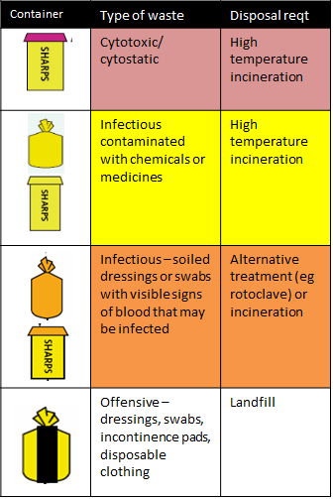

Figure 8. Safe Management of Healthcare Waste.

1. **Blood Borne Viruses (BBVs)**

BBVs are viruses that some people carry in their blood and which may cause severe disease in certain people with few or no symptoms at all in others. The virus can spread to another person whether the carrier of the virus is ill or not.

The main BBVs of concern are:

* Hepatitis B virus (HBV), Hepatitis C virus and Hepatitis D virus all which cause hepatitis - a disease of the liver.
* Human Immunodeficiency Virus (HIV) which causes Acquired Immune Deficiency Syndrome.
* (AIDS) affecting the immune system of the body. These viruses can also be found in body fluids other than blood, for example, semen, vaginal secretions and breast milk.
* Other body fluids or materials such as urine, faeces, saliva, sputum, sweat, tears and vomit carry a minimal risk of BBV infection unless these fluids or materials are contaminated with blood.
* Care should still be taken as the presence of blood is not always obvious and patients may not have any symptoms of a BBV.
* All staff at risk of exposure to BBVs should be vaccinated against Hepatitis B.
* Staff are at risk of BBV as much as patients are at risk of contracting BBV from staff.
* When on assignments, all cuts and abrasions should be covered with a waterproof dressing before providing care.
* Staff with skin conditions should seek advice from their own GP to minimise their own risk of infection through open skin lesions.
* The correct type of lancing device should be used for patients at home or in residential or nursing home settings who need to use a blood glucose monitoring device. This is to prevent the transmission of BBVs.

1. **Human Bites**

Human mouths are inhabited by a wide variety of organisms, some of which can be transmitted by bites. Human bites which break the skin are more likely to become infected than dog or cat bites, so it is important that they are treated promptly.

If a bite does not break the skin:

* Clean with soap and water
* Complete an incident form
* Review the risk assessment and identify if any changes are required to prevent incidents arising again

If a bite breaks the skin:

* Clean immediately with soap and water and cover with a dressing.
* Complete an incident form.
* Seek medical advice by going to the local A&E department; this will be to treat potential infection and for reassurance and information about HIV and Hepatitis B infection.
* Review the risk assessment and identify if any changes are required to prevent incidents arising again.

1. **Animal Bites**

* Most animal bites are less likely to become infected than human bites; however, they should still be taken seriously.
* In the UK, animal bites which do not break the skin should be washed with soap and water.
* If a bite breaks the skin, wash with soap and water then seek medical advice about the possible need for treatment to prevent infection.
* If someone becomes generally unwell or the bite looks infected, they should seek medical attention.
* Complete an incident form and review the risk assessment.
* The bite should be reported as a significant event and reviewed accordingly.
* Body fluid spillages – urine, vomit, faeces and blood.

1. **All Spillages of Body Fluids (e.g. urine, vomit, faeces or blood) Should Be Dealt with Immediately**

* Please ensure you use an appropriate spillage kit. Please follow the instruction on the pack on how to use the spill kit.
* Wear disposable non-latex gloves and a disposable apron.
* Absorb as much of the spillage as possible with absorbent paper towelling.
* This can be disposed of into a plastic waste sack (or flushed down the toilet/dirty utility sluice if small amounts)
* If indoors, clean the area with a neutral detergent, e.g. washing up liquid and hot water, rinse and dry and then ventilate the area.
* For spillages outside the premises, sluice the area with hot water.
* Do not forget to thoroughly wash your hands after you have taken your gloves off.
* It is recommended that, where there are carpets or soft furnishings, these should be thoroughly cleaned with warm soapy water or a proprietary liquid carpet shampoo, rinsed and, where possible, dried.
* Consent must be obtained from the patient if the incident occurs in their home and patch testing of the carpet or fabric should be undertaken.

1. **Outbreaks of Communicable Diseases**

* Business continuity plans should include provision for outbreaks of communicable diseases, e.g. where staff may be severely depleted and unable to treat patients.
* Staff members making nursing/care home visits and visits to patients at home must be aware of the signs of infection, e.g. fever, diarrhoea and/or vomiting, unexpected falls and confusion, particularly in the elderly. They must also know to report these signs immediately to the senior management of the nursing/care home when they are detected. A number of infectious diseases spread quickly and easily and cause outbreaks.
* Ensure you comply with any national or local guidelines as these will take precedence.

1. **Skin Infections / Infestations**
   * 1. Staff members who require close physical contact with patients in order to diagnose or provide treatment should be informed via an alert on the clinical system if a patient has a known skin infection or infestation. If a patient with a skin infection or an active or partially treated infestation requires admission to hospital, the admitting hospital should be informed of the condition. For general advice or guidance on the infection or infestation, United Kingdom Health Security Agency [UKHSA] can be contacted.
     2. If a member of staff reports that they have acquired a skin infestation, they should seek advice and treatment from their GP and communicate with their line manager before returning to work. In the case of infestations such as scabies, once the first treatment has been completed the employee may return to full duties although itching may persist for several weeks. The staff member's whole family and close contacts will require treatment at the same time. Appropriate risk assessments should be carried out in respect of staff members with identified skin infections/infestations and relevant action taken.
2. **Disposal of Waste**

* Some waste from healthcare (also called clinical waste) may prove hazardous to those who come into contact with it and is subject to stringent controls.
* Hypodermic needles and other types of hazardous healthcare waste should never be disposed of in the toilet or sink, only in a sharps container and according to the manufacturers' recommendations.
* Where Patients are treated in their home, any waste produced as a result is considered to be the healthcare professional’s waste.
* If the waste is non-hazardous, and as long as it is appropriately bagged and sealed, it is acceptable for the waste to be disposed of with household waste. This is usually the case with sanitary towels, nappies and incontinence pads (known collectively as sanpro waste) which are not considered to be hazardous when they originate from a healthy population.
* If the waste is classified as hazardous, arrangements should be made to correctly dispose of the waste safely.
* Where hypodermic needles and other sharps are used in the patient's home, sharps bins should be used.
* In the case of pharmaceuticals (medicines etc.) the recommended means of disposal is to return them to a pharmacist. If this is not possible, local authorities are obliged to collect the waste separately when asked to do so by the waste holder, although they may make a charge to cover the cost of collection.
* If patients treat themselves in their own home, any waste produced as a result is considered to be their own. Only where a particular risk has been identified (based on medical diagnosis) does such waste need to be treated as hazardous clinical waste.

*The Health and Social Care Act Code of Practice* states that the risks from waste disposal should be properly controlled.

In practice this involves:

* Assessing risk.
* Developing appropriate policies.
* Putting arrangements in place to manage risks.
* Monitoring the way in which arrangements work.
* Being aware of legislative changes.

1. **Sepsis**

Sepsis is a common and potentially life-threatening condition triggered by an infection. Sepsis causes the body's immune system to go into overdrive and, if it not treated quickly, it can lead to multiple organ failure and death. In many cases, however, sepsis is avoidable and treatable and early identification is key to successfully treating sepsis.

The St. Martins Medical Centre will participate in the Sepsis Awareness campaigns. The key to preventing sepsis is to prevent an infection from occurring in the first place. If an infection does set in it must be treated as quickly and effectively as possible.

Many illnesses can be and are prevented through regular childhood vaccinations and any vaccinations available as an adult.

The risk of getting an infection also reduces with proper hand washing. Infections can also be reduced by proper care of all wounds. Staff should understand and recognise the signs of sepsis (see Further Reading)

Figure 9. How to Spot Sepsis in Adults

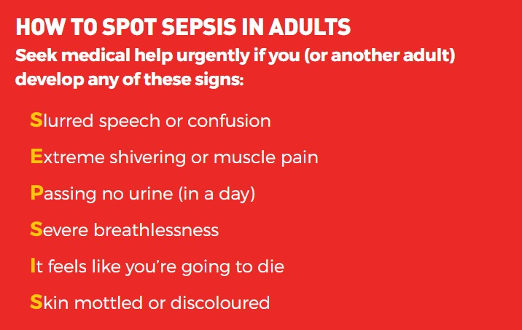

Figure 10. How to Spot Sepsis in Children Under 5

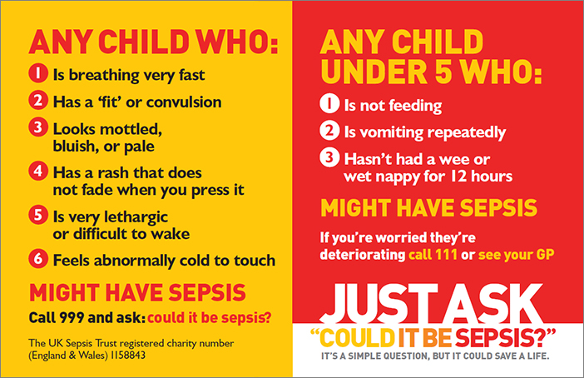

1. **Reporting**

UKHSA aims to detect possible outbreaks of disease and epidemics as rapidly as possible. Accuracy of diagnosis is secondary, and since 1968 clinical suspicion of a notifiable infection is all that is required.

‘Notification of infectious diseases’ is the term used to refer to the statutory duties for reporting notifiable diseases in the Public Health (Control of Disease) Act 1984 and the Health Protection (Notification) Regulations 2010.

Registered medical practitioners (RMPs) have a statutory duty to notify the ‘proper officer’ at their local council or local health protection team (HPT) of suspected cases of certain infectious diseases.

Information on the 'proper officer' should be kept up to date and available to all members of staff.

Complete a notification form immediately on the diagnosis of a suspected notifiable disease. Don’t wait for laboratory confirmation of a suspected infection or contamination before notification.

Send the form to the 'proper officer' within 3 days or notify them verbally within 24 hours if the case is urgent by phone or encrypted email.

Please ensure you inform the Infection Control Lead Nurse and the partners as soon as possible.

Notifiable diseases include:

* Acute encephalitis
* Acute meningitis
* Acute poliomyelitis
* Anthrax
* Botulism
* Brucellosis
* Cholera
* Diphtheria
* Enteric fever (typhoid or paratyphoid fever)
* Food poisoning
* Haemolytic uraemic syndrome (HUS)
* Infectious bloody diarrhoea
* Invasive group A streptococcal disease
* Legionnaires’ disease
* Leprosy
* Malaria
* Measles
* Meningococcal septicaemia
* Mumps
* Plague
* Rabies
* Rubella
* Severe acute respiratory syndrome (SARS)
* Scarlet fever
* Smallpox
* Tetanus
* Tuberculosis
* Typhus
* Viral Haemorrhagic Fever (VHF)
* Whooping cough
* Yellow fever

Health protection legislation in England gives public authorities powers and duties to prevent and control risks to human health from infection or contamination, including by chemicals and radiation.

**Appendix 3**

**Definitions and Explanation of Terms**

**A**

ABHR: See alcohol-based hand rub

Airborne precautions: Actions taken to prevent or minimize the transmission of infectious agents or organisms that remain infectious when suspended in the air.

Airborne transmission: A means of spreading infection in which airborne droplet nuclei are inhaled by uninfected people.

Alcohol-based hand rub (ABHR): A method of hand hygiene that includes an alcohol containing preparation designed for application to the hands for reducing the number of viable microorganisms on the hands. ABHR is not an alternative for washing with soap and water if hands are visibly soiled.

Antibiotic: Type of antimicrobial agent made from a mould or a bacterium that kills, or slows the growth of other microbes, specifically bacteria. Examples include penicillin and streptomycin.

Antibody: A protein found in the blood that is produced in response to foreign substances (e.g., antigens) invading the body. Antibodies protect the body from disease by binding to these organisms and destroying them. Antimicrobial agents: A general term for the drugs, chemicals, or other substances that either kill or slow the growth of microbes. Among the antimicrobial agents in use today are antibacterial drugs (which kill bacteria), antiviral agents (which kill viruses), antifungal agents (which kill fungi), and ant parasitic drugs (which kill parasites).

Antimicrobial resistance: The result of microbes changing in ways that reduce or eliminate the effectiveness of drugs, chemicals, or other agents to cure or prevent infections. Examples include multidrug resistant organisms (MDROs) such as methicillin-resistant Staphylococcus aureus (MRSA). Also known as drug resistance.

Antiseptic: A germicide that is used on skin or living tissue for the purpose of inhibiting or destroying microorganisms. Examples include alcohols, chlorhexidine, chlorine, hexachlorophene, and iodine.

Asepsis: Prevention from contamination with microorganisms. Includes sterile conditions on tissues, on materials, and in rooms, as obtained by excluding, removing, or killing organisms. B Bacteria: Single-celled organisms that live in and around us.

**B**

Bacteria may be helpful, but in certain conditions may cause illnesses such as strep throat, most ear infections, and pneumonia.

Blood borne viruses: Disease-producing microorganisms spread by contact with blood or other body fluids from an infected person. Examples include hepatitis B and C as well as HIV.

Body Fluids: Blood; excretions like urine, faeces, vomit, meconium, lochia; secretions like saliva, tears, sperm, colostrum, milk, mucous secretions, wax, vernix; exudates and transudates like lymphatic, pleural fluid, cerebrospinal fluid, ascites fluid, articular fluid, pus (except sweat); organic samples like tissues, cells, organ, bone marrow, placenta.

**C**

Case: A person with symptoms.

Carrier: A person (host) who harbours a micro-organism (agent) in the absence of discernible clinical disease. Carriers may shed organisms into environment intermittently or continuously and therefore act as a potential source of infection.

Cleaning: The removal of visible soil, organic, and inorganic contamination from a device or surface, using either the physical action of scrubbing with a surfactant or detergent and water or an energy based process with appropriate chemical agents.

Clostridium difficile: An anaerobic, gram-positive, spore-forming bacillus that can cause diarrhoea and other intestinal diseases when competing bacteria in the gut are diminished by antibiotics. Clostridium difficile-associated Disease (CDAD): An intestinal illness caused by toxins that are produced by a specific type of bacteria named Clostridium difficile.

Contact precautions: Type of transmission-based precautions that requires barrier precautions for direct contact with resident or objects/surfaces contaminated with an infectious agent.

Contamination: The presence of an infectious agent on a body surface or on clothes, gowns, gloves, bedding, furniture, computer keyboards, or other inanimate objects that may be capable of producing disease or infection

Colonisation: The presence of micro-organisms at a body site(s) without presence of symptoms or clinical signs of illness or infection. Colonisation may be a form of carriage and is a potential method of transmission.

Commensal: A micro-organism resident in or on a body site without causing clinical infection. Communicable period: The time in the natural history of an infection during which transmission may take place.

Communicable diseases: Communicable diseases can be defined as illnesses caused by micro-organisms and transmitted from an infected person or animal to another person or animal. Some diseases are passed on by direct or indirect contact with infected persons or with their excretions. Most diseases are spread through contact or close proximity because the causative bacteria or viruses are airborne, i.e. they can be expelled from the nose and mouth of the infected person and inhaled by anyone in the vicinity. Such diseases include diphtheria, scarlet fever, measles, mumps, whooping cough, influenza and smallpox. Some infectious diseases can be spread only indirectly, usually through contaminated food or water, e.g. typhoid, cholera and dysentery. There are other infections that are introduced into the body by animal or insect carriers, e.g. rabies, malaria and encephalitis.

Contact: An exposed individual who might have been infected through transmission from another host or the environment.

**D**

Decontamination: A process or treatment that renders a medical device, instrument, or environmental surface safe to handle because it is no longer capable of transmitting particles of infectious material. Disinfectant: A chemical agent used on inanimate (non-living) objects to destroy virtually all recognized pathogenic microorganisms, but not necessarily all microbial forms (e.g., bacterial spores).

Disinfection: The destruction of pathogenic and other kinds of microorganisms by physical or chemical means. Disinfection is less lethal than sterilization, because it destroys most recognized pathogenic microorganisms, but not necessarily all microbial forms, such as bacterial spores.

Droplet precautions: Actions designed to reduce and prevent the transmission of pathogens spread through close respiratory or mucous membrane contact with respiratory secretions.

Droplets: Small particles of moisture that may be generated when a person coughs or sneezes or when water is converted to a fine mist by an aerator or shower head. Droplets may contain infectious microorganisms and tend to quickly settle out from the air; therefore, risk of disease transmission is generally limited to persons in close proximity to the droplet source.

**E**

Endemic: The usual level or presence of an agent or disease in a defined population during a given period.

Endogenous infection: Micro-organisms originating from the service user’s own body which cause harm in another body site. Epidemic: An unusual, higher than expected level of infection or disease by a common agent in a defined population in a given period.

Exogenous infection: Micro-organisms originating from a source or reservoir which are transmitted by any mechanism to a person, i.e. contact or airborne routes.

**F**

FFP3 Mask: see particle filter respirator.

Flora: Micro-organisms resident in an environmental/body site. Hand care: Actions to prevent skin irritation.

**G**

Gastroenteritis: Inflammation of the stomach and the intestines that causes symptoms such as nausea, vomiting, and diarrhoea.

Gastrointestinal (GI) infection: See gastroenteritis.

**H**

Hand hygiene: A general term that applies the following: 1) hand washing with antimicrobial/non-antimicrobial soap and water or 2) antiseptic hand rub (waterless antiseptic product, most often alcohol based, rubbed on all surfaces of hands).

Healthcare-associated infection (HAI): An infection that develops in a patient who is cared for in any setting where healthcare is delivered and is related to receiving health care. Formerly known as nosocomial infection.

Hypochlorite: A chlorine (bleach) based disinfectant.

**I**

Immunization: The process or procedure by which a subject is rendered immune, or resistant to a specific disease. This term is often used interchangeably with vaccination or inoculation, although the act of inoculation/vaccination does not always result in immunity.

Immunocompromised: Those whose immune mechanisms are deficient because of congenital or acquired immunologic disorders (e.g., human immunodeficiency virus [HIV] infection), chronic diseases (e.g., diabetes mellitus, cancer, emphysema), malnutrition, or immunosuppressive therapy of another disease process.

Infection: The invasion of the body by pathogenic microorganisms and their multiplication which can lead to tissue damage and disease.

Influenza: Also known as flu. A serious and sometimes deadly respiratory infection that can spread quickly in a community.

Invasive procedure: A medical procedure that involves entering the body, usually by cutting or puncturing the skin or by inserting instruments into the body.

**L**

Latent tuberculosis infection (LTBI): A condition in which living tubercle bacilli (M. tuberculosis) are present in the body but the disease is not clinically active.

**M**

Mask: A term that applies collectively to items used to cover the nose and mouth and includes both procedure masks and surgical masks. Microorganisms: An organism that can be seen only with the aid of a microscope and that typically consists of only a single cell.

Microorganisms include bacteria, fungi, parasites, and viruses. MRSA: See methicillin-resistant Staphylococcus aureus.

**N**

Needle stick or Sharps Injury: A needlestick (or sharp) includes items such as needles, sharp-edged instruments, broken glassware, any other item that may be contaminated with blood or body fluids and may cause laceration or puncture wounds, such as razors, sharp tissues, spicules of bone and teeth.

Norovirus: A very contagious virus transmitted from person-to-person or via contaminated food, water, or objects, causing outbreaks of vomiting and diarrhoea.

Nosocomial infection: See healthcare-associated infection.

Nitrile: A synthetic rubber made from organic compounds and cyanide.

**O**

Outbreak: An outbreak can be defined as two or more cases of infection occurring around the same time, in patients and/or their family members or carers or an increase in the number of cases normally observed. The commonest outbreaks are due to viral respiratory infections and gastroenteritis. The organisms may be spread by hand contact and, on occasion, by other routes, which may include food.

**P**

Particle filter respirator (PFR): Facemasks which are designed to protect the wearer from inhaling small airborne particles, including microorganisms. They are made to defined performance standards that include filtration efficiency. To be effective they must be fitted close to the face to minimise leakage.

Personal protective equipment (PPE): A variety of barriers used alone or in combination to protect mucous membranes, skin, and clothing from contact with infectious agents. PPE includes gloves, masks, respirators, goggles, face shields, and gowns.

Post-exposure Prophylaxis (PEP): Drug treatment regimen administered as soon as possible after an occupational exposure where there is indication of HIV to reduce the risk of acquisition.

**R**

Reservoir: Any animate or inanimate focus in the environment in which an infectious agent may survive and multiply and which may act as a potential source of infection.

**S**

Safety needle device- Any device designed to reduce the risk of injury associated with a contaminated needle. This may include needle-free devices or mechanisms on a needle, such as an automated re-sheathing device, that cover the needle immediately after use.

Sepsis is a life-threatening condition that arises when the body's response to an infection causes it to attack its own tissues and organs. In sepsis, a patient’s immune system goes into overdrive setting off a series of reactions including widespread inflammation. This can cause a significant decrease in blood pressure, reducing the blood supply to vital organs and starving them of oxygen. Sepsis can lead to multiple organ failure and death especially if not recognised early and treated quickly. Staff members can spot the early signs of Sepsis by using the Sepsis Tool.

Seroconversion: The development of antibodies not previously present resulting from a primary infection. Sharps: Instruments used in delivering healthcare that can inflict a penetrating injury, e.g. needles, lancets and scalpels.

Sharps injury: An injury that results in a sharp instrument/object, e.g. needle, scalpel, cutting or puncturing the skin.

Single Use: indicates that the device can only be used once and then must be discarded.

Source: Place where micro-organisms are growing or have grown.

Sporadic case: A single case which has not apparently been associated with other cases, excreters or carriers in the same period of time.

Sterile: Free from all living micro-organisms for the purpose of the item.

Sterilisation: A process that removes or destroys all micro-organisms including bacterial spores. Standard precautions: A group of infection prevention practices that apply to all patients, regardless of infection status. Standard precautions are based on the principle that all blood, body fluids, secretions, excretions except sweat, non-intact skin, and mucous membranes may contain transmissible infectious agents. Standard precautions include hand hygiene, and depending on the anticipated exposure, use of gloves, gown, mask, eye protection, or face shield. Also, equipment or items in the patient environment likely to have been contaminated with infectious fluids must be handled in a manner to prevent transmission of infectious agents. Formerly known as universal precautions.

Surgical masks: A mask that covers the mouth and nose to prevent large droplets from the wearer being expelled into the environment. As these masks are generally also fluid repellent they also provide some protection for the wearer against exposure of mucous membranes to splashes of blood/body fluid.

**T**

Transmission: The method by which any potentially infecting agent is spread to another host.

Transmission-based precautions: A set of practices that apply to patients with documented or suspected infection or colonization with highly transmissible or epidemiologically important pathogens for which precautions beyond the standard precautions are needed to interrupt disease transmission.

**V**

Vaccine: A product that produces immunity therefore protecting the body from the disease. Vaccines can be administered by injection, mouth, or aerosol.

Virus: A microorganism smaller than bacteria that cannot grow or reproduce apart from a living cell. Examples include influenza, chicken pox, hepatitis, and HIV.

**Equality and Health Inequalities Analysis**

The Equality Analysis is a written record that demonstrates that you have shown due regard to the need to eliminate unlawful discrimination, advance equality of opportunity and foster good relations with respect to the characteristics protected by the Equality Act 201

|  |  |  |
| --- | --- | --- |
| Date of assessment | October 2022 | |
| Name of person completing the EIA | NN | |
| Job Title | Infection Control Lead | |
| The following questions determine whether analysis is needed: | | |
|  | | Yes / No |
| Does the policy significantly affect service users, employees or the wider community?  The relevance of a policy to equality depends not just on the number of those affected but on the significance of its effect on them | | No |
| Is it likely to affect people with particular protected characteristics differently? (Age, disability, gender reassignment, marriage/ civil partnership, pregnancy & maternity, race, religion and belief, sex, sexual orientation). | | No |
| Is it a major policy, significantly affecting how The St. MartinsMedical Centre activity is delivered? | | No |
| Will the policy have a significant effect on how partner organisations operate in terms of equality? | | No |
| Does the policy relate to functions that have been identified through engagement as being important to people with particular protected characteristics? | | No |
| Does the policy relate to an area with known inequalities? | | No |
| Does the policy relate to any equality objectives that have been set by The St. MartinsMedical Centre Hillingdon CIC? | | No |

If the answer to all of these questions was no, then the assessment is complete.

If the answer to any of the questions was yes, then undertake the analysis below:

|  |  |
| --- | --- |
|  | Yes / No / Comment |
| Do policy outcomes and service take-up differ between people with different protected characteristics? |  |
| What are the key findings of any engagement you have undertaken? |  |
| What are the key findings of any engagement you have undertaken? |  |
| If there is a greater effect on one group, is that consistent with the policy aims? |  |
| If the policy has negative effects on people sharing particular characteristics, what steps can be taken to mitigate these effects? |  |
| Will the policy deliver practical benefits for certain groups? |  |
| Does the policy miss opportunities to advance equality of opportunity and foster good relations? |  |
| Do other policies need to change to enable this policy to be effective? |  |
| Additional comments |  |